

# BODY PARAGRAPH ASSIGNMENT

# Name: Eisha

# Sec: C-2 (CS)

# ID: 17K-3730

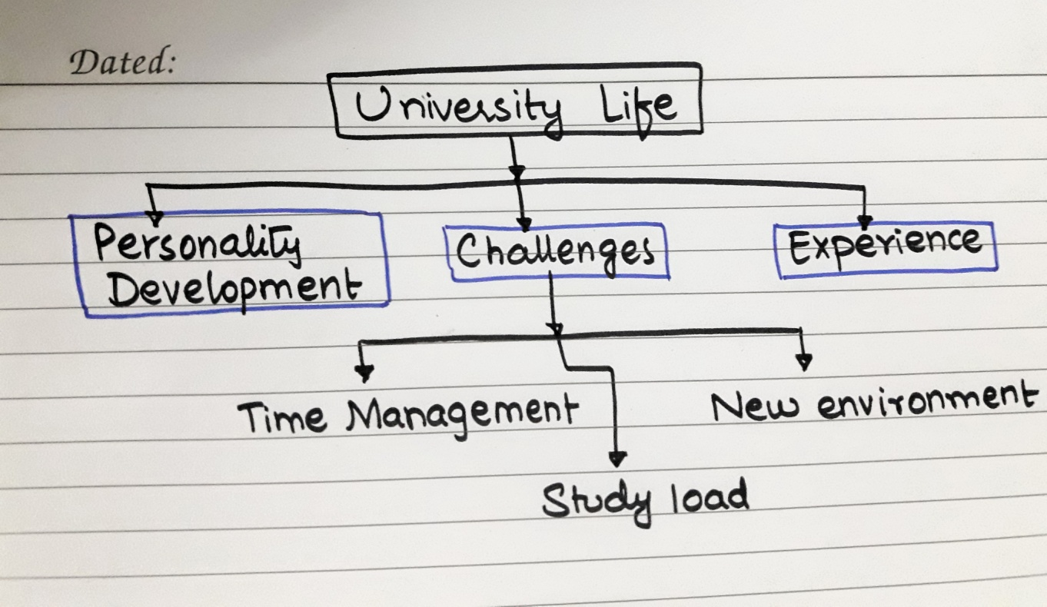**Generating ideas:**

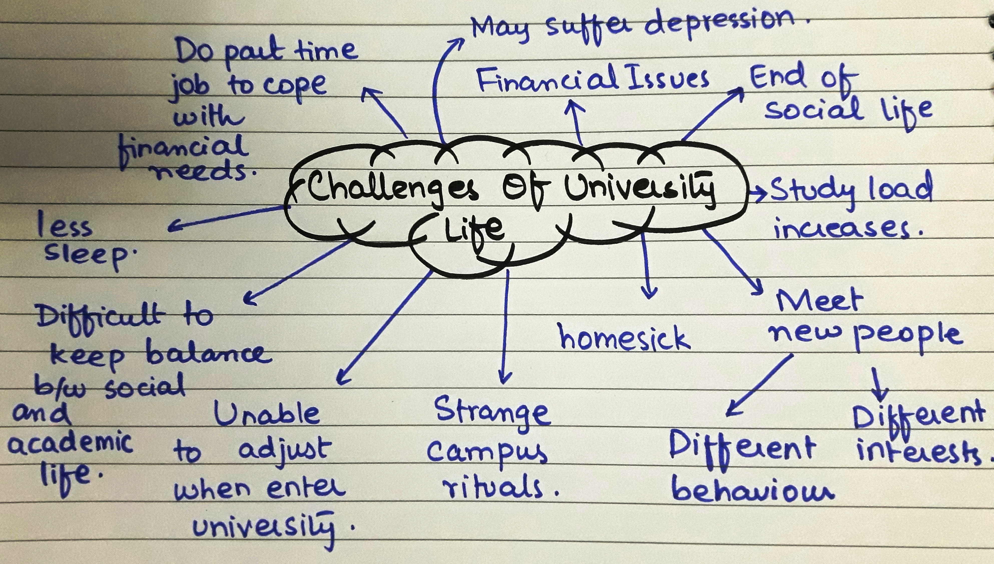

# Topic: University life

Narrowed Topic: Challenges *of university life.*

### Topic sentence:

University life is the second name of challenges where students have many things to deal with.

### Main point 1: Adapting new environment

* Campus cultures are strange to many students.
* They are unable to adjust in new environment.
* Some students feel hesitant to meet new people with different interests.

### Main point 2: Pressure of Studies

* End of social life.
* Students run after GPA and main focus on learning is diverted toward the race of getting good grades.
* Become homesick.

### Main point 3: Time management

* Students are unable to keep balance between studies and other activities.
* Some do part time job to cope with their financial needs .
* Confused to choose between **‘sleep’** and **‘to do list’**.

# Body Paragraph:

Students often find their university life to be the most challenging period of their life where they have to confront many difficulties. The main challenge faced by them is the new campus environment. Many students find it difficult to adjust with campus cultures and feel hesitant to meet new people with different interests. The second challenge is the pressure of studies and dealing with the peer pressure at the same time. Many students run after good grades and GPA, and their main focus on learning is diverted toward the race after good grades. Many students suffer from depression which may have a bad impact on their mental health. The third thing is time management; students are mostly unable to maintain a balance between their academic and social activities which leads to the end of social life. At the same time, some do part time jobs to meet their financial needs due to which it’s difficult for them to focus on studies. Usually, they get confused to choose between **‘sleep’** and **‘to do list’**, but once they prepare themselves to overcome these social and personal challenges their university life become the best experience.